Chapter 17, Problem 61.

The spectra of the Fourier series of a function are shown in Fig.17.84. (a) Obtain the trigonometric Fourier series. (b) Calculate the rms value of the function.

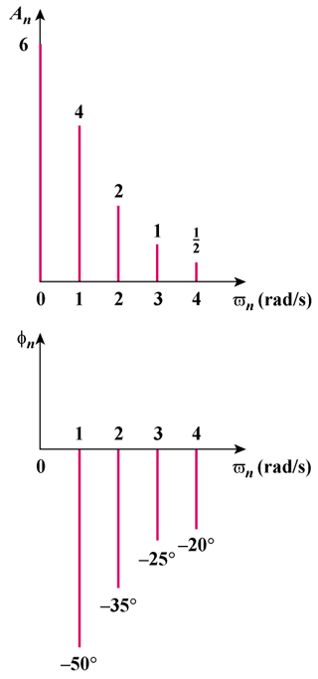

Figure 17.84
For Prob. 17.61.

